AEM AUTHOR PORTFOLIO ASSIGNMENT

1.Header:

The header should include the following pages:

* Home
* Books
* About Me
* Contact Me

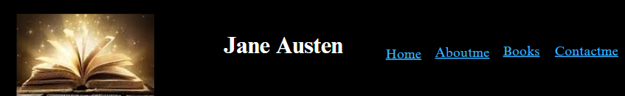

2.Footer:

1. About Me – Add a short description of the author.
2. Books List – Display all book links as a hyperlinked list (books should open in a new tab).
3. Social Media Section – Add social media icons with links to the author's social profiles.

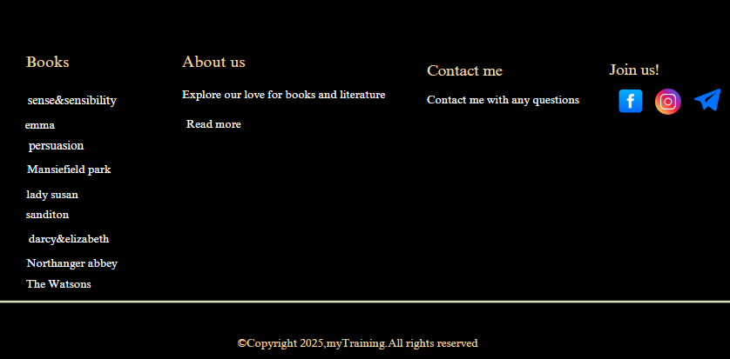

3.Home page:

Use the OOTB Teaser Component to display an award ceremony for the author.

The Teaser Component should include:

* Image (award ceremony picture)
* Title & Description

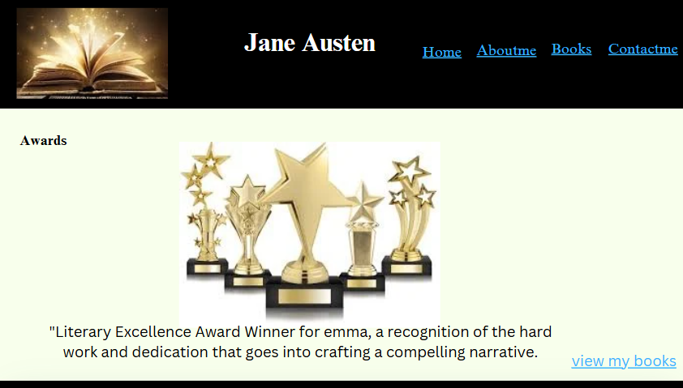

4.About me page:

Add a necessary information of the author

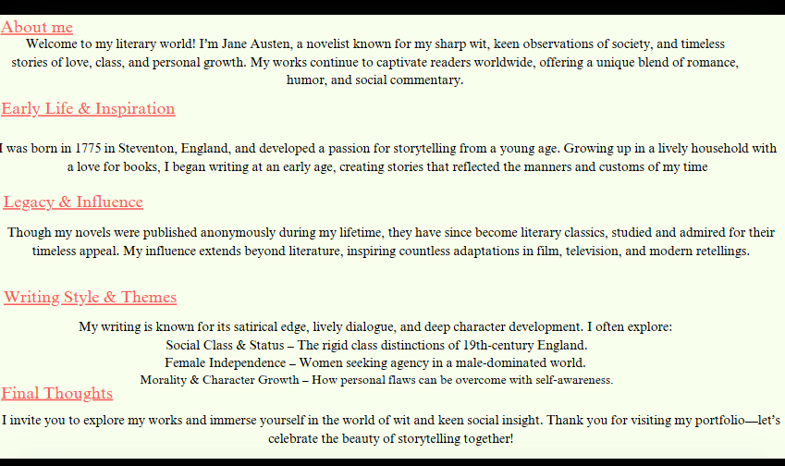

5.Books page:

Create a Custom "Book" Component that fetches books dynamically from the /content/books/ hierarchy.

The Books Page should contain:

* Book Cards (each showing the book’s title, image, and description).
* Each card should have a clickable link (to view full book details).
* Ensure all books are placed under /content/books in the content hierarchy.

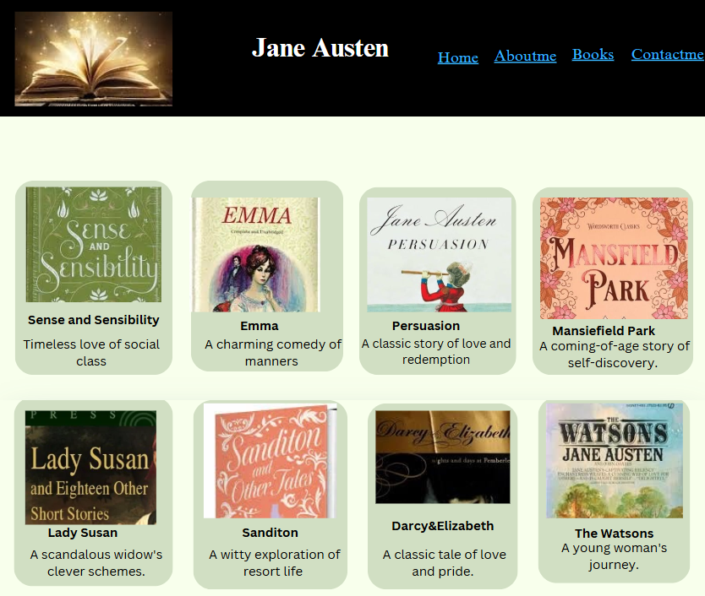

6.Contact me page:

Use text and Teaser Components to display:

* Email, Phone, Social Media links.

Steps:

1. Drag & Drop Text Component for contact details.
2. Add Teaser Component for a professional look.

Ensure submit button is working.

